|  |
| --- |
| Kingswood School |
| Survival of the fittest teaching aid |
| Comp4 project |

|  |
| --- |
| 9525 Alex Robinson |

Contents

Section 1: Analysis 4

The problem: identification and background 4

Description of available tools 5

Identification of prospective users 7

Identification of user needs and acceptable limitations 7

Data sources and destinations 9

Data volumes 9

Analysis Data Dictionary 10

Data Flow Diagrams 10

Objectives for the proposed system 11

Appraisal of potential solutions 12

Justification of chosen solution 14

Section 2: Design 15

Overall system design 15

Description of modular structure of system 17

Definition of data requirements (Design Data Dictionary) 17

Validation required 17

Identification of storage media 17

Identification of suitable algorithms for data transformation, pseudo code of these algorithms 17

Class definitions (diagrams) and details of object behaviours and methods 17

User interface design (HCI) rational 17

UI sample of planned data capture and entry designs 21

UI sample of planned valid output designs 21

Description of measures planned for security and integrity of data 21

Overall test strategy 22

Section 3: Technical Solution 22

Section 4: System Testing 22

Section 5: System Maintenance 22

Section 6: User Manual 22

Section 7: Evaluation 22

Appendix A: Availability of Teaching Materials on Evolution 22

Appendix B: Evolution – the main concepts 24

**Further work required to Analysis section**

Do sources have to be quoted (e.g. those used for research) and credited?

More comparisons with current systems

Update to remove references to admin interface and login, have pupils type in names and class when enter system. No need for extra complications of login process. Have create class button to track people only in certain class.

Fix rulers/grid, padding of titles is uneven

Remove score boards to decrease complexity

# Section 1: Analysis

## The problem: identification and background

### Problem identification

The problem addressed in this project is to develop a computer-based tool which will enable secondary school teachers of Biology at a school in Bath to illustrate how evolution occurs in a population. This problem was identified from interviews with Biology teachers which found that the subject of evolution is complex and difficult to teach to younger pupils (aged around 12-13).

These interviews found that pupils in this age range find it difficult to grasp the abstract ideas of evolution as this involves following an argument with several stages to it and a number of novel concepts such as ‘genes’, ‘mutation’, ‘selection’ and ‘inheritance’. The interviews also found that presentations and handouts failed to capture the dynamic nature of evolutionary change and ‘bring it to life’. Further, due to a shortage of suitable tools and materials it is difficult for teachers to set meaningful classroom exercises on evolution and to encourage pupils to do independent learning outside of the classroom.

As a result of these problems in teaching the topic teachers have found that some pupils can have common misconceptions about natural selection. For example, some pupils persist in believing in Lamarckism - the idea that an organism can pass on characteristics that it acquired during its lifetime to its offspring. It was felt, in the interviews, that a computer-based tools could illustrate the process of evolution, enable pupils to have more of a ‘hands-on experience’ and could be an excellent way for pupils to understand for themselves why ideas such as Lamarckism are wrong - rather than being taught simply that they are wrong.

Online research and face-to-face interviews with teachers (see Appendix A for details) has shown that there are many types of videos, handouts, presentations and other written materials currently available for school teachers on the subject of evolution. In addition, there are some computer-based tools which simulate how evolution occurs and which can, for example, allow different timescales and types of populations to be selected and different simulations to be run. These computer-based tools are evaluated and a new solution is developed in this project.

### Background - Teaching context

The teachers who were initially interviewed teach Biology teachers and each have two classes a year of 15 – 20 mixed ability twelve to thirteen year old pupils. Evolution is taught as part of a Combined Sciences course in an introduction to the natural world and a 40 minute lesson is devoted to it. In these lessons the teachers cover the following:

* Some context – the ideas of Charles Darwin.
* A definition of evolution.
* An overview of how it occurs – introducing a number of ideas including the existence of differences within a population, members of a population being more/less suited to their environment, natural selection and the lengthy timescales over which evolution generally occurs.
* Examples are introduced – these can include more material on Darwin, on his travels and the Galapagos Islands, and well-known examples of evolution such as Darwin’s finches or the evolution of butterflies in contemporary Britain and their response to pollution.
* What evolution is not/common misconceptions – Lamarckism.
* Lessons are a mixture of explanation by the teacher, using video or written materials to illustrate the subject, taking questions and classroom discussion.

Computers with internet access are available during lessons with one computer for every pupil.

## Description of available tools

Description of current system? Should this be put in feasibility studies?

The two Biology teachers who have been interviewed are not currently using any computer-based simulation tools as part of their lessons on evolution. However, some tools do exist and this section assesses the leading examples.

The tools assessed fall into two categories: a) tools focused specifically on evolution, and b) more broadly-based tools - for example considering the impact of disasters on animal populations. The table below summarises the tools which have been assessed.

|  |  |  |
| --- | --- | --- |
| **Name** | **Description** | **Assessment** |
| **“Who Wants to Live a Million Years?”** | * Aimed at 12- 14 age group * Focused on evolution * Learning and simulation sections, together with a quiz, glossary and Darwin biography * Shows impact of a change in environment on a population and the effects of natural selection | * Learning and simulation sections * Poor treatment of mutations * Poor representation of gradual evolution processes * Not very engaging/fun * Minimal user interaction * Overall – too high level |
| **“Stop Disasters!”** | * Aimed at 16+ age group * Produced by the United Nations * Focused on disaster recovery * Shows the impact of disasters | * Engaging and sophisticated * Good level of user interaction * Good information and links * Not relevant to evolution |
| More to be added |  |  |

The tool “Who Wants to Live a Million Years?” (<http://science.discovery.com/games-and-interactives/charles-darwin-game.htm>) is an example of a free independent learning tool designed to help teach the concept of evolution. It is a flash-based web application aimed at teaching the basic concepts of evolution by demonstration. The content and graphics indicate that it is aimed at pupils from about 12 – 14.

The tool contains a learning section (‘Learn about Evolution’) and a simulation section (‘Play the Survival Game’). The learning section shows the user both text and pictures in a fun, animated way to help engage users. The simulation section proceeds as follows:

* It asks the user to choose a starting population and select variations within the population.
* It then demonstrates the impact of several changes in the environment (e.g. a warmer climate, a new predator or a natural disaster) on the numbers of the population - to show how only those best suited to the new environment will survive and reproduce while the others will not.
* If a population is wiped out the user is asked if they want to return to the beginning and select a different set of characteristics to test whether they will improve survivability.
* The simulation takes about 2 minutes to complete each time, with users expected to run several simulations.

A number of criticisms of this tool can be made:

* The simulation gives a misleading representation of natural selection as it presents mutations as a non-random event (as selected by the user) while in reality they are totally random and cannot be chosen.
* It is not clear what the different mutations are - different versions of an animal are shown in crude terms (e.g. one has longer fur, another has a longer body).
* The results of a change in environment are simply presented – there is no explanation why the different versions are increasing or decreasing in number
* The simulation is also not very engaging; there is minimal user interaction (which does not make it fun) with just a few clicks from start to finish.
* Overall, the tool is aimed at young children to provide some ‘fun’ but it provides only a very crude view of evolution.

Another example of a flash-based web application based in flash is “Stop Disasters!” ([http://www.stopdisastersgame.org](http://www.stopdisastersgame.org/)). The focus of “Stop Disasters!” is not evolution but preventing and responding to disasters – it is produced by the United Nations and the International Strategy for Disaster Reduction. It is aimed at older children than “Who Wants to Live a Million Years” and has a game section, a section on high scores from the game, information on the largest disasters in recent history and teacher resources about disasters such as tsunamis.

The simulation tool can be used to teach students about disaster prevention, as part of geography or other lessons. The objective of the game is to assess the risk of a disaster and to reduce the damage to the human population when one does occur. The simulation section proceeds as follows:

* The user selects a scenario e.g. ‘Coastal Village – tsunami’, and difficulty level (which is generated by the level of detail of the maps used).
* A disaster occurs and the user is given a mission e.g. ‘construct accommodation for 400 people with a budget of $35,000).
* The user then spends the budget to purchase various materials.
* A score is shown e.g. number of population successfully housed.
* The simulation takes about 10 minutes to run, depending on the choices made by the user.

“Stop Disasters!” is much more sophisticated and interesting than “Who Wants to Live a Million Years?” as it allows the user to interact with it more fully, it has better graphics and feels more like a game with choices – rather than a few simple steps over which the user has little influence. It does not deal with evolution but is a good example of a sophisticated interactive learning tool.

More examples to be added

In summary, the current tools which have been analysed have a number of advantages and disadvantages and none have been judged to meet all the relevant criteria. While “Who Wants to Live a Million Years?” is focused on evolution it has a number of drawbacks in the user experience and in the level of detail it shows about evolutionary processes. “Stop Disasters!” has a better user experience, being fun and informative and with significant user interaction, but is not focused on evolution.

## Identification of prospective users

Two types of users of the system have been identified – teachers in the classroom and pupils. Teacher users are teachers of Biology who conduct classes for 12-13 year olds at Kingswood School in which an introduction to evolution is required. Class sizes are from 10-15 pupils. The teacher users have a good knowledge of computing and applications but are not IT specialists. Teachers will use the tool to demonstrate the basic concepts of evolution to the pupils, and will act as an administrator for the tool.

Pupil users are aged 12-13, are of mixed ability and have already had some background in science. They lack any detailed knowledge of evolution, although they are likely to have heard of it, and may find the idea challenging. The pupil users know how to follow simple instructions on a computer and use simple applications. Pupils will use the tool to see how the concepts of evolution taught to them in the classroom can be illustrated and ‘brought to life’.

## Identification of user needs and acceptable limitations

Analysis of user needs and acceptable limitations has been undertaken for both sets of users – teachers and pupils.

### User needs – teachers

Teachers require a tool that quickly and easily illustrates the concept of evolution in a manner that is understandable and interesting to children and which is easy to administer. Teachers’ more detailed requirements are:

1. A tool which **illustrates the concept of evolution**. This concept is summarised in Appendix B. The main ideas of the concept of evolution should all be covered:
   1. Organisms have genes which determine their makeup.
   2. As a result of the mutation of genes, variations capable of being inherited exist within populations of organisms.
   3. Organisms produce more offspring than can survive.
   4. These offspring, with their different inheritances, vary in their ability to survive and reproduce.
   5. In conditions with competition between organisms for survival and reproduction those organisms with traits that give them an advantage over their competitors pass these advantageous traits on, while traits that do not confer an advantage are not passed on to the next generation. As a result we have the ‘survival of the fittest’ and a gradual change in populations – they change or may even die out.
2. As a teaching tool there **should not be a steep learning curve** i.e. the tool should not be over complex in its ideas, as this would defeat the point of simplifying the teaching of the concept.
3. As the tool is for teaching it **must be an accurate illustration** of the concept of evolution.
4. The tool should provide a **simulation involving movement** since evolution involves dynamic change and a static tool is not appropriate.
5. As the tool is to be used as both a teaching tool and a tool to prompt independent learning/further study into the subject area by pupils the tool must be able to be **used within the classroom** (or computer room) as well as **by the pupils in their own time or for homework at home**.
6. The tool needs to be **able to be used by 12-13 year old pupils**, either individually or in small groups of 4-6, and must be **extremely simple to use** with minimum tutoring required – no more than 5 minutes.
7. **Setting up and running a simulation should take no more than 5 minutes** per simulation by pupils.
8. **Total time for using the tool** – from instruction to the analysis of results – **should be about 22 minutes.**
9. The tool must be **portrayed in a way to best engage this age group,** together with any linking content suitable for this age group. The tool must be fun and engaging.
10. All pupils in the classroom and outside the classroom should have **equal access to the tool** and there should be **no minimum system requirements** (e.g. owning a smart phone), so that everyone can use it.
11. When first introduced, **the tool must be demonstrated by a teacher through a projector** so that the pupils can get the most out of the tool and so that it is used correctly and all features used to their maximum effectively.
12. The simulation should **not be expected to be completely accurate** and approximations may be made so not to increase the complexity of the simulation beyond the scope of the teaching.

### User needs – pupils

1. The tool must be **suitable for 12-13 year olds** in terms of the complexity of content and the ease of use.
2. It must be **fun and engaging** – that is, pupils should enjoy each simulation and want to run several.
3. It must be capable of **communicating clear learnings**.
4. It must be capable of being **accessed by all pupils**.

### Software

1. The simulation must work on the major web browsers:
   1. Internet explorer 9 and upwards (current school version).
   2. Firefox version 20 and upwards.
   3. Chrome version 22 and upwards.

### Hardware

1. The simulation must run smoothly on a … computer which the the average spec computer in the schools computer rooms.
2. Only a mouse and keyboards can be used as input devices for the system as these are all that are provided by every work station.
3. The simulation should be able to scale up to resolutions larger then 800x600 so that it can be displayed on a projector.

### Simulation

1. The simulation should not be expected to model realistic ant movement it should only be expected to model a 2d representation of ant movement.
2. The simulation should not be expected to model a realistic environment.
   1. However should simulate basic regenerating food sources.
   2. Should only simulate a 2d terrain.
3. The simulation should not simulate the complete life cycle of ants i.e. ants are born fully grown.
4. The simulation should not model the inner workings of the nest only the concept of the nest is where the Queen lives and new ants are born and where food is stored.

## Data sources and destinations

1. The teacher will input names in the system to be used as logins for the pupils. There will be 10–15 names, and these will be stored and also outputted on the admin interface so that the teacher can check each name. There will be minimal processing on this input - just checking that they are unique.
2. The pupils will input values through buttons and sliders into the simulation via the user interface. The values selected will be used to change how the simulation runs and will therefore require heavy processing (running through the simulation).The simulation will output the result in an animation onto the screen.

## Data volumes

There will be two teachers who will each use the tool for half a lesson (22 minutes) and prep once a year. While using the program the 10-15 pupils will update the simulations values once every 20-30 seconds on average. Only the top 5 scores will be scored for each school, with each record in the database the score, school and name is stored.

Estimates of sizes

## Analysis Data Dictionary

* **Characteristic** – A variable feature of an ant which changes it in some way e.g. how fast it can move.
* **Species** – A collection of unique characteristics define an new species in the simulation
* **Mutation** – A random event which alters a characteristic
* **Ant** **nest** – The home of the Queen ant and where it reproduces as well as a general food store
* **Queen** **ant** – The head of the species and the only ant capable of reproducing
* **Worker Ant** – An ant whose purpose is to collect food and supply it to the nest
* **Soldier Ant** – An ant whose purpose is to guard the nest and other ants from attack. And also to attack ants of a different species.
* **Pheromones** – Chemicals deposited by ants when they move which can be detected by antennae’s and used to alert other ants of danger or as a trial to food. Pheromones concentration slowly degrades over time due to evaporation.
* **Alert pheromone** – Deposited by ant to alert other ants of danger and to attract soldier ants to defend against the danger.
* **Trial pheromone** – Deposited by worker ants and used as trials to food.
* **Score** – The number of generations the users chosen species survives for.

## Data Flow Diagrams

### Entry relation diagrams

This is not applicable to my project.

May be needed for backend database to track scores.

### Object analysis diagrams

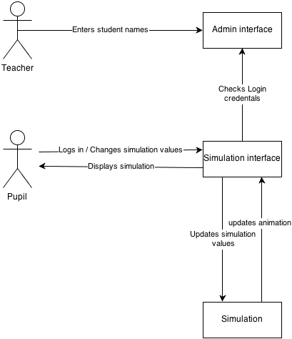

Figure 1 - Object relationship diagram

Once design is done update this relationship diagram

OUT OF DATE – no admin interface any more + show saving high scores

## Objectives for the proposed system

### Ant simulation objectives

1. The simulation should be able to generate realistic (e.g. has a gradient) random food placement.
2. The simulation should be able to create random maps (food and obstacles)
3. The ants should have variable basic characteristics Including:

3.1. Speed the ants move

3.2. The lifespan of the ants

3.3. The reproduction rate

3.4. The amount of food ants are able to carry

3.5.

1. The simulation should be able to introduce random mutations and events such as natural disasters into the system to change the environment (so pupils can see how the ants must suited to the environment will survive).
2. The simulation should model energy intake from food needed for ant to survive depending on the size and speed of the ants so not to make it unfair.
3. The simulation must model a nest.
4. The simulation must model basic types of ants (e.g. worker, queen, solider).
5. The simulation must be able to model fighting of ants.
6. The simulation must run smoothly on [system requirements] systems as well as the average speed home computer.
7. The simulation must model fermion trails including:

10.1. Their creation when an ant is moving

10.2. Their evaporation due to conditions

10.3. How ants respond to the trials

10.3.1. Following to find food.

10.3.2. Avoiding exploring.

10.3.3. Following back to nest.

10.3.4. Detecting invaders.

### Simulation interface features objectives

1. Pause and play buttons to pause and play simulation.
2. Navigation buttons to move around the simulation.
3. Two levels of zoom to view ant activity and overall nest spread.
4. For each species (displayed when selecting nest) statistics measuring:
   1. Death rate.
   2. Birth rate.
   3. Nest food.
   4. Number of ants in species.
   5. Length of time species has survived.
5. (?) Graphs of species statistics over time.
6. Very easy to navigate for 12-13 year olds with standard icons (e.g. left facing arrow for back button).
7. Must be interesting to look at with use of colours and shapes to keep interest of pupils.

### General objectives

1. Must be able to be setup quickly (less than 5 minutes by pupil).

Repeat limitations as objectives e.g. must work on internet explorer?

## Appraisal of potential solutions

### Smart phone app

A smart phone app written in Java (android) or Objective-C (IOS) would run the simulation on a phone which would connect to a remote server to keep track of high scores.

This would fulfil the majority of the requirements:

* Due to smart phone portability the app could be used both inside and outside the classroom.
* Phones are internet-enabled and so can log into a remote server.
* The age group are familiar with the concept of apps and would be familiar with the interface.
* Smart phones are powerful enough to run a complex biological simulation and could maintain simulation accuracy.

However, there are some disadvantages from a smart phone solution. Not all pupils would have a smart phone and as a result not everyone in the class would be able to use the app. The availability of the mobile network may change suddenly and terminate simulations/not update scores – network availability may also be poor in some of the pupils’ home locations. Furthermore, due to the fragmentation of smart phone operating systems the same app would need to be written for multiple different architectures (IOS, android …) - possibly making the project unviable. Lastly, if the exercise is done in class there would be no way to know if the pupils where using the tool or using their phones for another use.

### Web application

A web application written in HTML5 and JavaScript with a server side database is another potential solution. Using the web has a number of advantages.

* The internet is available on school and home computers.
* Access to the tool would not be a problem as almost everyone has access to a computer (i.e. school computer lab) thus for filling the users requirements.
* Even young pupils are very familiar with web application interfaces and as such teachers would only be required to provide a short introduction and pupils could quickly learn how to use the application.
* There would be little issue with cross compatibility as both html and JavaScript are web standards and implemented in all modern browsers including mobile browsers.
* As the speed of JavaScript has increased dramatically an accurate simulation should be able to run smoothly.

However the complexity of the project may increase due to the use of multiple languages (HTML, CSS, JavaScript, and MYSQL) and the added complication of configuring and maintaining a web server and domain.

### Desktop application

A desktop application written in C++ with a server backend could be used. This would have a number of advantages:

* The simulation could easily run due to C++’s speed and also access to a desktop.
* Like the web application in (HTML5, JavaScript) it could be used by all of the pupils at home or in the classroom for filling the Dr Shefrons objectives.
* A connection to a server could be used to update the scores in real time.

Although the application would have to be cross compatible between the major operating systems (Windows, Mac and Linux) in order to make sure everyone could use it on their machine increasing the complexity of the program. Furthermore the increased setup time of the tool would make it less user friendly (i.e. user must download and install the program). Also as the school uses remotely served applications from a virtual server the school would need to install the program on all the computers not just the ones needed for the biology students.

### Pen and paper simulation

A non-technical solution to the problem would be to create a set of rules and then use counters on a gridded board to simulate how the ant’s behaviour would change depending on their input values. Random mutations could be introduced by using a die.

* The simulation could be used all of the pupils.
* The simulation does not need computers and therefore the students do not have to change room, increasing the amount of time available.

However the simulation would be far too slow and the pupils may not be able to see the overall patterns emerging from it and therefore not learn the concepts of evolution. It would require more than one pupil to be fun and engaging and so cannot be done at home as you cannot guarantee pupils can have other pupils over. There is no way of comparing results between pupils apart from manually asking each pupil how long their species lasted. The scale of the simulation would be dramatically reduced and would be less impressive as a result making the simulation less interesting to pupils.

## Justification of chosen solution

The chosen solution is a website based simulation written in HTML5, CSS and JavaScript and using a webserver and MYSQL database backend to record the high scores. This was chosen as the solution because it allows for all of the objectives to be achieved to their full with the least additional complexity.

* All simulation objectives can be accomplished due to JavaScript’s speed.
* The simulation can be easily displayed in an aesthetically pleasing manner with CSS to engage the pupils.
* The tool requires very little preparation time as it only requires the browser which is already installed on school computers.
* The tool can be easily used at home by pupils as it is a website and can be navigated too from anywhere with internet and a web browser (which is assumed they have).
* The tool can be easily displayed through a projector and should be able to scale to any sized monitor.
* The tool will have a shallow learning curve as pupils already know how to navigate webpages.

Survey/interviews

Analysis of current systems/observation

# Section 2: Design

Diagrams needed:

* Overall system flow chart (website + simulation + scores + login)
* Ant behaviour diagrams (same as ant algorithm )
  + General behaviour
  + Solider behaviour
  + Worker behaviour
  + Queen behaviour
* User interface design
  + UI for webpages (login, main)
  + UI for simulation
* Class/object diagrams
  + OO diagram for ants (Queen?)
  + OO diagram for map/environment
* Database diagrams
  + Scoring system (no database stored logins)

## Overall system design

### The simulation

The simulation will simulate the principles of survival of the fittest by using ants. It will both simulate ant society structure as well as a basic environment for the ants to move in.

#### Evolution

Each species of ant will have a separate set of characteristics which defines it. During the creation of new queens random mutation can occur altering these characteristics creating a new species. The better the characteristics suit the environment the more likely that the species will continue to survive collect food which in turn means more ants so the species lives longer. The characteristics for the simulation are (characteristics - traits):

* **Eye sight** – Controls how far an ant can see
* **Antenna size** – Controls the lowest concentration of pheromones ant can detect
* **Exoskeleton thickness** – Increases amour however decreases speed
* **Jaw strength** – Increase fighting damage
* **Jaw size** – Allows more food to be carried at once
* **String size** – Increase fighting damage
* **Speed** (? Biological/genetic traits?)– Increase how fast an ant can move
* **Pheromone** **concentration** – Increase max concentration of pheromones produced (both alert and trial)

The main limiting factor for all of the characteristics is food, the more favourable a characteristic is e.g. bigger eyes, the larger the amount of food the ant will need to eat every x turns/ticks.

#### Ant behaviour

All ants must eat a certain amount of food every x turns/ticks otherwise they will lose health. Ants will have different amounts of health depending on their genetic characteristics, if health is below 0 the ant dies.

There will be three types of ant:

* **Worker ant** – The worker ant is responsible for finding, collecting and bringing food back to the nest.
* **Soldier ant** – The soldier ant is responsible for attacking other ant colonies destroying their nest or killing ants from the other nest to disrupt their collection of food leading to the collapse of the nest because of starvation. Similarly Soldier ants are also responsible for defending ants from attack from other species and also defending the nest.
* **Queen ant** – Creates a nest, and reproduces new ants.

Pheromones will also be simulated, there will be two types:

* **Trial pheromones** – These are continually laid down by worker ants, they will slowly diffuse into surrounding areas and will also slowly evaporate in the environment. When looking for food ants will wander around randomly laying down a trial, once they find food they follow their trial back to the nest to return it and then repeat the journey to collect more food. Each time more pheromones will be laid down making the path more concentrated. Ants will be more likely to follow very concentrated routes when looking for food. Soldier ants will act as sentries and stand along busy trials defending their worker ants.
* **Alert pheromones** – These will be expelled when any ant is attacked and spread out very quickly. Worker ants (who cannot fight) will avoid these areas while soldier ants will head towards the centre of the pheromone to defend/fight what every attacked one of their ants.

Nests will be simulated very minimally, after the initial simulation starts and the first queen starts reproducing it will create both soldier ants and worker ants but also new queen ants in a user defined ratio. When a new queen is created there is a chance of random mutation and the characteristics which define the species change (creating a new species). The queen will then fly away from the nest where it was born and create a new nest and start creating new ants, if the queens characteristics where mutated and it forms a new species it will become competition for other species.

#### Interface

At the start of the simulation the user will adjust the characteristics of the first colony or choose random characteristics. Once the simulation is run there is no further user control of the simulation. During the simulation the user will be able to track the progress of their species as well as monitor the progress of other species viewing statistics like:

* Number of ants
* Birth rate
* Death rate
* Total food in nest
* Survival time

The user will have two levels of zoom in the simulation, one to view the individual ant’s behaviour and the other to view all the nests. As well as zooming the user will be able to pan around the simulation. Each characteristic has a specific colour and the mix of these colours gives the species a unique colour.

## Description of modular structure of system

## Definition of data requirements (Design Data Dictionary)

## Validation required

## Identification of storage media

The scores will be saved to a remote server

## Identification of suitable algorithms for data transformation, pseudo code of these algorithms

## Class definitions (diagrams) and details of object behaviours and methods

## User interface design (HCI) rational

### Interface

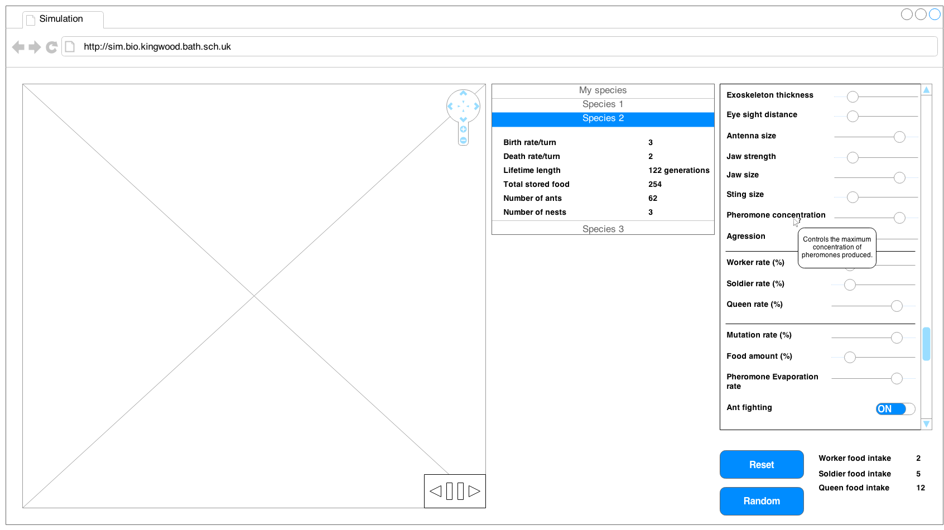

**6**

**5**

**4**

**3**

**2**

**1**

The tools interface is simple and is split up into three main sections:

* The simulation section on the left is where actions related to the presentation of the simulation are shown such as Item 1 is a set of navigation buttons used to move around the simulation and zoom in and out. Item 2 is time control buttons, back a tick, pause/play, and forward a tick.
* The Next section to the right of the simulation show at item 3 is real time statistics Panel displaying how each species of ants is progressing, statistics are displayed when the pupil selects the specific species. Statistics are displayed individually for each species rather than all species at the same time to decrease the amount of screen space used and also to make it more obvious which statistics the pupil is viewing. This section was placed next to the simulation as it is directly affected to how the simulation plays out.
* The final section on the far left of the screen at item 4 is the characteristics customisation panel. This panel contains all of the customizable characteristics for a species as well as relevant selection tool e.g. slider, toggle button. Item 5 shows the effect of a mouse over, each setting in the panel when hovered over displays a brief message as to what the setting changes. Within the characteristic customisation panel there are three sections separated by horizontal ruled lines. The sections are used to group relevant settings together to allow quicker navigation to related settings. Item 6 shows two buttons which are used to reset the characteristics to default settings and to select random settings respectfully. Next to these are the food intake indicators, as explained in overall system design the more favourable a characteristic is there more food is required by an ant, these indicators display the relative food intake for each type of ant. These are displayed at the bottom outside of the scrollable settings so that they can always be viewed when changing the characteristics.

### Simulation

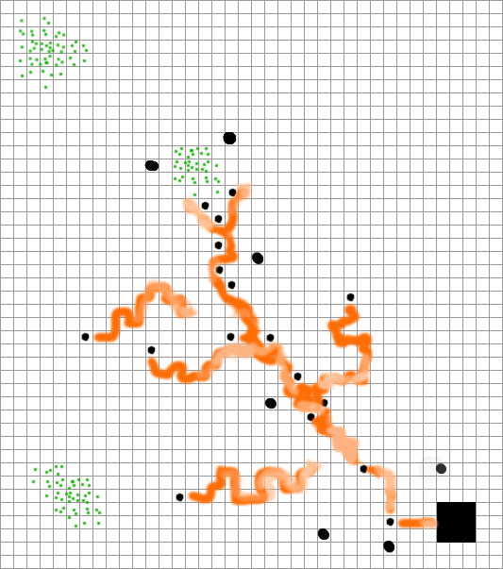

#### Colours

In the simulation each unique characteristic will have a specific colour, the strength of the characteristic gives the vibrancy of the colour, and the mix of these colours gives the species its colour. This is done so species with similar characteristics can be spotted and more easily compared.

Food is displayed as green a colour often associated with leaves, grass… which are the food the ants (most like leafcutters) eat in real life.

Pheromones in the simulation will be displayed in the colour of the ant species however a much lighter tint, the strength of the pheromone determines the opacity of the colour so if there is lots of pheromones with a higher concentration or newly laid pheromones then the colour will be more vivid showing that is more active and recent while older more stagnant trials will be very light, as to not attract attention from the pupil.

#### Shapes

* Worker ants – Displayed as circles, basic and easy to see however no to differentiate between different ants of the same species so no need for more complex shapes. Choose not to use ant like shapes as rotation of them would create too much on screen movement.
* Soldier ants – Displayed as larger circles, again no real need to have complex shape to differentiate individual ants by as this is not important, it is the main overall picture which counts.
* Nests – Displayed as large 3 by 3 squares, no need for complex shape, will be easy to see overall picture with simple shapes.
* Food – Displayed as a collection of dots, the amount of dots in a square represents the amount of food in that square, this is done so the pupils can more easily estimate the relative food amounts in a certain area just by glancing at them.
* Pheromones – Displayed as long trials behind the ants much like they are in real life, this is done to show to the user the use of pheromones.

## UI sample of planned data capture and entry designs

Data within this tool is gathered from the editing of characteristics each characteristic has its own input field, the fields are chosen to limit the amount of user error in the input. Sliders and toggle switches are the only two data capture types. Sliders are used when a range of values within a limit must be chosen, they are chosen rather than spinners as they can be used with only the mouse, this is the same with a toggle button.

## UI sample of planned valid output designs

## Description of measures planned for security and integrity of data

Security is not a major concern of this project as no sensitive personal information is stored or recorded as only the top x scores are saved and are displayed on the website along with a user chosen name and are therefore accessible by anyone anyway.

### Anti-cheating

Ideas:

* Run copy simultaneously on server to check scores are realistic
* Send progressive report every ... ticks and check

## Overall test strategy

# Section 3: Technical Solution

# Section 4: System Testing

# Section 5: System Maintenance

# Section 6: User Manual

# Section 7: Evaluation

# Appendix A: Availability of Teaching Materials on Evolution

### Online research

The following sources illustrate the types of materials which are available for school teachers on the subject of evolution and related subjects (such as conservation).

|  |  |  |
| --- | --- | --- |
| **Website** | **Materials available** | **Assessment** |
| http://www.arkive.org/education/  (searched 2/10/13) | * Presentations, teacher notes and spreadsheets on numbers of Finch variations in the Galapagos Islands and on peppered moths * Aimed at 14-16 and 16-18 age groups | * Focus on conservation * Attractive materials * No online or computer simulation tools on evolution but some data which can be used in classrooms |
| More to be added |  |  |

### Interviews

Two interviews with Biology teachers have been conducted at Kingswood School, Bath. The findings were as follows:

* xx
* xx

Additional interviews will be undertaken with teachers at other schools.

# Appendix B: Evolution – the main concepts

From Wikipedia – entry on ‘Evolution’

“Evolution by means of [natural selection](http://en.wikipedia.org/wiki/Natural_selection) is the process by which genetic mutations that enhance reproduction become and remain more common in successive generations of a population. It has often been called a "self-evident" mechanism because it necessarily follows from three simple facts:

* Heritable variation exists within populations of organisms.
* Organisms produce more progeny than can survive.
* These offspring vary in their ability to survive and reproduce.

These conditions produce competition between organisms for survival and reproduction. Consequently, organisms with traits that give them an advantage over their competitors pass these advantageous traits on, while traits that do not confer an advantage are not passed on to the next generation.

The central concept of natural selection is the [evolutionary fitness](http://en.wikipedia.org/wiki/Fitness_%28biology%29) of an organism.[[96]](http://en.wikipedia.org/wiki/Evolution#cite_note-Orr-96) Fitness is measured by an organism's ability to survive and reproduce, which determines the size of its genetic contribution to the next generation. However, fitness is not the same as the total number of offspring: instead fitness is indicated by the proportion of subsequent generations that carry an organism's genes.[[97]](http://en.wikipedia.org/wiki/Evolution#cite_note-Haldane-97) For example, if an organism could survive well and reproduce rapidly, but its offspring were all too small and weak to survive, this organism would make little genetic contribution to future generations and would thus have low fitness.

If an allele increases fitness more than the other alleles of that gene, then with each generation this allele will become more common within the population. These traits are said to be "selected *for*". Examples of traits that can increase fitness are enhanced survival and increased [fecundity](http://en.wikipedia.org/wiki/Fecundity). Conversely, the lower fitness caused by having a less beneficial or deleterious allele results in this allele becoming rarer — they are "selected *against*". Importantly, the fitness of an allele is not a fixed characteristic; if the environment changes, previously neutral or harmful traits may become beneficial and previously beneficial traits become harmful. However, even if the direction of selection does reverse in this way, traits that were lost in the past may not re-evolve in an identical form.”

Search undertaken 8/10/2013